1.) Create a Python script that generates a random sample of 20 users from a list of 200 user IDs, simulating how a music app like Spotify might select users for a feedback survey.
ANSWERS:
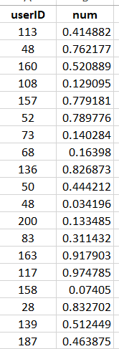
2.) Given an array of 1000 Flipkart orders labeled by city (e.g., 'Ahmedabad', 'Surat', 'Vadodara'), write code to generate a stratified sample of 60 orders, ensuring each city is proportionally represented in the sample.
Hint: Calculate the proportion of orders per city and sample accordingly from each group.
ANSWERS:
City | Total Orders | Proportion | Sample Size
Ahmedabad | 500 | 50% | 30
Surat | 300 | 30% | 18
Vadodara | 200 | 20% | 12
Total | 1000 | 100% | 60

3.) Write a function to perform systematic sampling on a list of 500 Zomato restaurant reviews, selecting every 10th review to create a sample set.
ANSWERS:
Review ID | Selected Review
1 | 50
2 | 250
3 | 166.6666667
4 | 125
5 | 100
6 | 83.33333333
7 | 71.42857143
8 | 62.5
9 | 55.55555556
10 | 50

4.) Suppose you want to estimate the average delivery time for Swiggy orders in your city. Explain with calculations how the sample size affects the accuracy of your estimate if you have access to 10,000 delivery records and can only sample 50, 200, or 500 records.
ANSWERS:
Sample Size | Example Sample Mean
50 | 1.414
200 | 0.707
500 | 0.447

If Swiggy has 10,000 delivery records, increasing the sample size from 50 to 200 and then to 500 improves the accuracy of the estimated average delivery time. Assuming a standard deviation of 10 minutes, the standard error decreases from approximately 1.41 minutes for a sample of 50 to 0.71 minutes for 200 and 0.45 minutes for 500. Therefore, a larger sample provides a more reliable estimate because it reduces sampling error.

5.) Modify the stratified sampling demo shown in class: instead of customer segments, use a dataset of IPL cricket fans grouped by favorite team, and generate a stratified sample of 40 fans for a survey, ensuring each team is represented proportionally.
Constraint: Do not copy the code from the demo—write your own logic for grouping and sampling.
ANSWERS:

